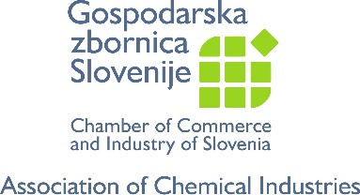
Web-Meeting
Industrial Emissions Directive – Common Waste Gas in the Chemical Sector (WGC) BREF
Nov 4th, 2020 10.00-11.30

AGENDA
10.00 1. Welcome, short introduction about the meeting, rules of conduct
10.10 2. Importance of BREFs and IED to the Central EU countries in general and Slovenia
in particular (Bostjancic, Dovc, Gospodarska zbornica Slovenije)
10.25 3. IED update, update other BREFs – ‘what is going on’ (Drees, Cefic)
10.30 4. WGC BREF – introduction/activities thus far (Drees, Cefic)
10.35 5. Q&A
10.40 6. Short Break/set up connection to Sevilla
10:45 7. Presentation by WGC BREF authors (Marty/Daginnus, JRC Sevilla)
11.00 8. Q&A session WGC BREF authors
11.10 9. WGC BREF: results of the view of industry, way forward
11.20 10: Q&A
11:25 11. Conclusions – messages from the CEE region to the EC/Sevilla team, action items, next meeting, Good Bye (other topics the audience is interested in? Repeat such meeting xx times/year?)
11.30 12. Adjourn

Dial-in instructions, see next page

Join Microsoft Teams Meeting
+32 2 897 19 25 Belgium, Bruxelles/Brussels (Toll)
Conference ID: 534 075 288#
Local numbers | Reset PIN | Learn more about Teams | Meeting options
Join with a video conferencing device
423577239@t.plcm.vc VTC Conference ID: 1259932417
Alternate VTC dialing instructions

